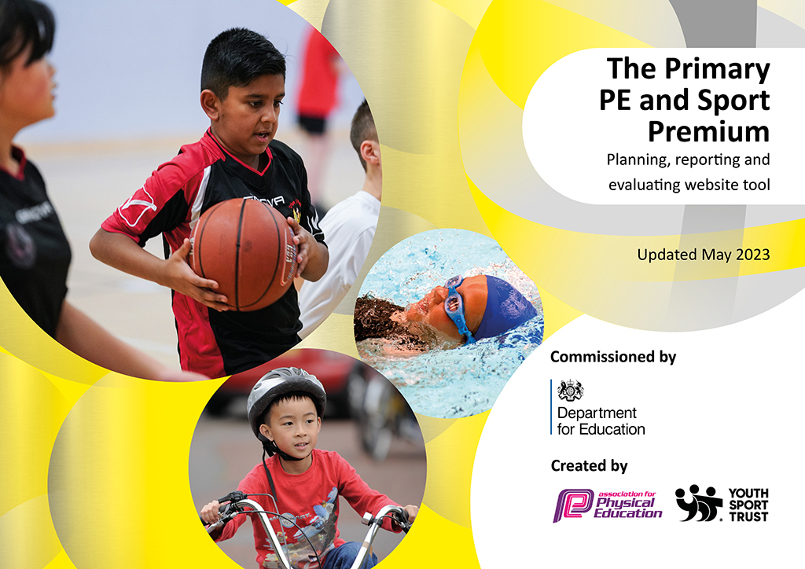
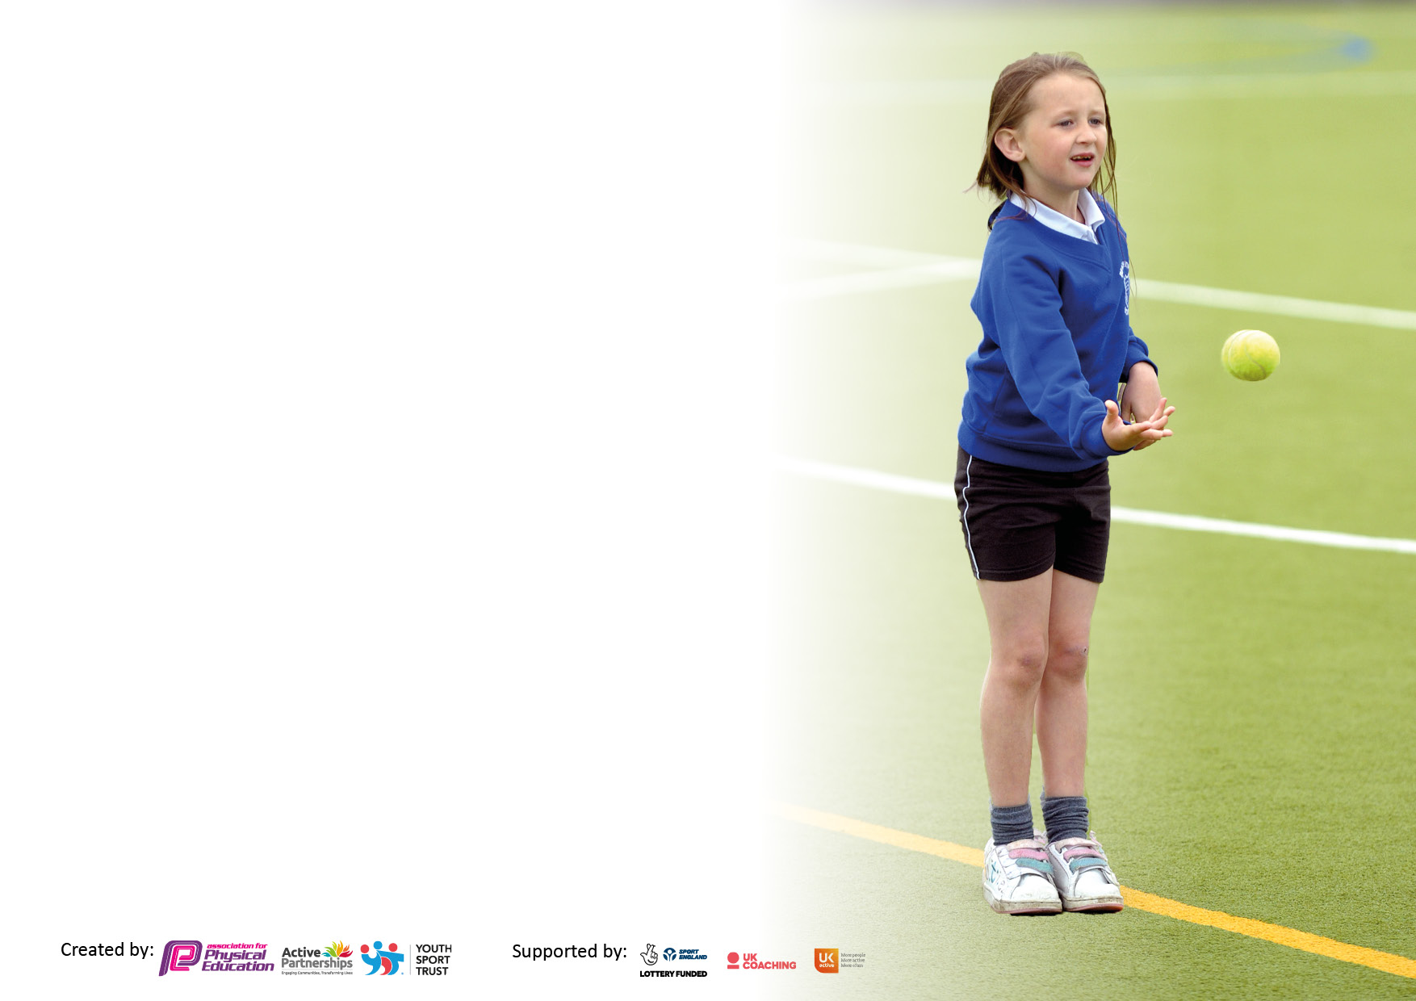

It is important that your grant is used effectively and based on school need. The Education Inspection Framework makes clear there will be a focus on ‘whether leaders and those responsible for governors all understand their respective roles and perform these in a way that enhances the effectiveness of the school’.

Under the Quality of Education Ofsted inspectors consider:
Intent - Curriculum design, coverage and appropriateness
Implementation - Curriculum delivery, Teaching (pedagogy) and Assessment
Impact - Attainment and progress

To assist schools with common transferable language this template has been developed to utilise the same three headings which should make your plans easily transferable between working documents.

Schools must use the funding to make additional and sustainable improvements to the quality of Physical Education, School Sport and Physical Activity (PESSPA) they offer. This means that you should use the Primary PE and sport premium to:

- Develop or add to the PESSPA activities that your school already offer
- Build capacity and capability within the school to ensure that improvements made now will benefit pupils joining the school in future years
- The Primary PE and sport premium should not be used to fund capital spend projects; the school’s budget should fund these.

Please visit gov.uk for the revised DfE guidance including the5keyindicatorsacrosswhichschoolsshoulddemonstrate an improvement. This document will helpyoutoreviewyourprovisionandtoreportyourspend.DfEencouragesschools to use this template as an effective way of meeting the reporting requirements of the Primary PE and Sport Premium.

We recommend you start by reflecting on the impact of current provision and reviewing the previous spend.

Schools are required to publish details of how they spend this funding, including any under-spend from 2021/2022, as well as on the impact it has on pupils’ PE and sport participation and attainment. The funding should be spent by 31st July but the DfE has stated that there will be no clawback of any unspent money so this can be carried forward into 2023/24.

We recommend regularly updating the table and publishing it on your website throughout the year. This evidences your ongoing self-evaluation of how you are using the funding to secure maximum, sustainable impact. Final copy must be posted on your website by the end of the academic year and no later than the 31st July 2023. To see an example of how to complete the table please click HERE.

Details with regard to funding
Please complete the table below.

Total amount carried over from 2021/22 | £4650
Total amount allocated for 2021/22 | £22,414
How much (if any) do you intend to carry over from this total fund into 2022/23? | £5500
Total amount allocated for 2022/23 | £23,260
22960 | £23,260
Swimming Data
Please report on your Swimming Data below.

Meeting national curriculum requirements for swimming and water safety.

N.B. Complete this section to your best ability. For example you might have practised safe self-rescue techniques on dry land which you can then transfer to the pool when school swimming restarts.
Due to exceptional circumstances priority should be given to ensuring that pupils can perform safe self rescue even if they do not fully meet the first two requirements of the NC programme of study
What percentage of your current Year 6 cohort swim competently, confidently and proficiently over a distance of at least 25 metres?  N.B. Even though your pupils may swim in another year please report on their attainment on leaving primary school at the end of the summer term 2023.  Please see note above | 54%
What percentage of your current Year 6 cohort use a range of strokes effectively [for example, front crawl, backstroke and breaststroke]?  Please see note above | 61%
What percentage of your current Year 6 cohort perform safe self-rescue in different water-based situations? | 12%
Schools can choose to use the Primary PE and sport premium to provide additional provision for swimming but this must be for activity over and above the national curriculum requirements. Have you used it in this way? | Yes/No

Action Plan and Budget Tracking
Capture your intended annual spend against the 5 key indicators. Clarify the success criteria and evidence of impact that you intend to measure to evaluate for pupils today and for the future.

Academic Year: 2022/23 | Total fund allocated: £23,260 | Date Updated: 25/07/23
Key indicator 1: The engagement of all pupils in regular physical activity – Chief Medical Officers guidelines recommend that primary school pupils undertake at least 30 minutes of physical activity a day in school |  |  |  | Percentage of total allocation:
 |  |  |  | 62%
Intent | Implementation |  | Impact
Your school focus should be clear what you want the pupils to know and be able to do and about  what they need to learn and to  consolidate through practice: | Make sure your actions to achieve are linked to your intentions: | Funding allocated:  £14,500 | Evidence of impact: what do pupils now know and what can they now do? What has changed?: | Sustainability and suggested next steps:
To engage children in 30 minutes of physical activity per day.  To provide sporting opportunities for a range of children | Children to complete a daily mile walk around the school grounds or take part in daily short exercise  Specialist multi-skills coaching at breakfast club 3 days per week and 1 ½ days PE provision - utilised between year groups.  This became a daily session for key worker and valuable children during lockdown and additional sessions in the afternoons for returning Y6 pupils.  Subscribed to the Primary Dance website and online support | No cost  £12,500 (including 1 ½ days of PE delivery between year groups)  £1200 | Children showing increased enthusiasm towards exercise.  Over the year some children showed increased physical fitness, being able to perform for longer periods or at increased levels than when they first began.  Children accessing a healthy start to the school day. | To continue to use the Daily Mile and Wake and Shake as a means of regular, school-wide exercise for pupils.  Use resource as a whole school level 1 competition. Introduce prizes for the most active class.
Key indicator 2: The profile of PESSPA being raised across the school as a tool for whole school improvement |  |  |  | Percentage of total allocation:
 |  |  |  | 12%
Intent | Implementation |  | Impact
Your school focus should be clear what you want the pupils to know and be able to do and about  what they need to learn and to  consolidate through practice: | Make sure your actions to achieve are linked to your intentions: | Funding allocated:  £3000 | Evidence of impact: what do pupils now know and what can they now do? What has changed?: | Sustainability and suggested next steps:
Develop children’s interest and desire to play and succeed in sports and physical activity.  Encourage and educate children in leading a healthy lifestyle. | External providers to continue to offer breakfast sports club.  External providers and school staff to continue to offer weekly after school clubs (cricket/dance/football/athletics)  Dance/drama Club offered after school  Fencing club  New equipment bought for Welfare staff to provide structured, competitive sporting activities for each Key Stage during lunch times.  Accrington Stanley held a learn to move programme with Year 5 for half a term | As noted above  £1000  Self-funded  £1250  £750  Funded by Accrington Stanley | Morning and after school extra-curricular clubs delivered to EYFS/KS/KS2 children.  Children take part in high quality PE lessons which is developing increased confidence and physical literacy. Children are becoming better skilled and are mastering FMS through regular participation in PE and school event | Continue to source external providers to deliver a range of activities.  Encourage parents to continue to fund sessions to aid sustainability.  Intra school competitions arranged and delivered.  Children prepared for and taken to SSP events and competitions.  Audit resources and equipment and purchase new/improved where required.

Key indicator 3: Increased confidence, knowledge and skills of all staff in teaching PE and sport |  |  |  | Percentage of total allocation:
 |  |  |  | 5%
Intent | Implementation |  | Impact
Your school focus should be clear | Make sure your actions to | Funding | Evidence of impact: what do | Sustainability and suggested
what you want the pupils to know | achieve are linked to your | allocated: | pupils now know and what | next steps:
and be able to do and about | intentions: |  | can they now do? What has
what they need to learn and to |  | £1150 | changed?:
consolidate through practice:
To increase the overall quality of PE teaching in school, maintain and share good practise.  Maintain the confidence of staff in curriculum delivery. | Staff have become more familiar with the Lancashire scheme of work and utilised this to inform and aid planning and delivery.  The PE co-ordinator has been available to advise and support staff where necessary.  School renewed subscription to the Lancashire online PE passport App – online assessment and planning resources | £750 for PE co-ordinator to provide support in planning and delivering sessions  £400 | PE co-ordinator was available for planning support and modelling of good practise to other staff one afternoon per week.  Staff utilised Lancashire Scheme of work and reported greater confidence in delivering the PE curriculum. Particularly when planning for progression.  Recording assessments can be immediate and easier through app, video and photographic evidence available. | Audit staff confidence and knowledge when delivering the PE curriculum.  Take greater advantage of SSP CPD opportunities.  Continue to work alongside class teacher to help improve their knowledge and confidence in teaching PE and delivering lessons confidently.  Staff to observe external coaches to develop and increase knowledge and confidence.
Key indicator 4: Broader experience of a range of sports and activities offered to all pupils |  |  |  | Percentage of total allocation:
 |  |  |  | 15%
Intent | Implementation |  | Impact
Your school focus should be clear | Make sure your actions to | Funding | Evidence of impact: what do | Sustainability and suggested
what you want the pupils to know | achieve are linked to your | allocated:  £750 | pupils now know and what | next steps:
and be able to do and about | intentions: |  | can they now do? What has | 3%
what they need to learn and to |  |  | changed?:
consolidate through practice:
Additional achievements:  Morning clubs offered 3x PW  A wider range of activities are now delivered across both key stages.  Member of Governing body willing to run a fencing club for school  New/improved resources bought | After school dance/drama classes offered to both Key Stages over the course of Autumn term  Multi-skills coaching offered to breakfast club attendees 4x pw.  Specialist core skills coaching for EYFS and Year 1 weekly.  Provide a different experience for children.  New and improved resources and equipment. | Covered in the costs above.  As noted in the costs above.  As noted in the costs above.  £750 | Children becoming more accomplished in basic skills required for physical literacy.  Greater engagement in different forms of exercise and sports.  Increased awareness of the importance of exercise and a healthy lifestyle.  Children have been introduced to specialist coaching in sports they may not have accessed otherwise.  Children able to access different activities and make use of better-quality resources and equipment. | Source and resource new activities for clubs and aim to have other staff deliver a club once allowed.  Take advantage of continued SSP membership to take part in virtual events and (use equipment available from Accrington Academy to introduce new sports and activities, if possible)  Look to build greater links with SSP schools and other local sports clubs (e.g. Accrington Stanley) to allow for possible wider engagement in sports.  Audit and monitor required resources throughout the year.

Key indicator 5: Increased participation in competitive sport |  |  |  | Percentage of total allocation:
 |  |  |  | 6%
Intent | Implementation |  | Impact
Your school focus should be clear | Make sure your actions to | Funding | Evidence of impact: what do | Sustainability and suggested
what you want the pupils to know | achieve are linked to your | allocated: | pupils now know and what | next steps:
and be able to do and about | intentions: |  | can they now do? What has
what they need to learn and to |  |  | changed?:
consolidate through practice:
Provide opportunity for children to engage in competition level sporting events. | Signed up to Hyndburn and Ribble Valley Schools Sports Partnership | £1250 | Children able to represent school in sporting events over the course of the year.  Children developing a sense of pride and responsibility when representing their school.  Competing at a more competitive level.  Learning the values of sportsmanship and fair play outside of the school setting. | Ensure all children in KS2 have opportunity to represent the school in a competitive event.  Increase the amount of level 2 events through links with local schools.  Join the Accrington Academy led SSP again  SSP will provide: Inter-school competitions and festivals (virtual until further notice. SSCO support-a specialist PE teacher who will work with the Sports Co-ordinator to support PE and schools sport delivery, and school games mark applications.  Increase the profile of intra-house competition in school, to develop sense of achievement in success - hold regular ‘competition weeks’ within school time so all children can access Level1 events, once allowed.

Signed off by
Head Teacher: | Karen Hardman
Date: | 27.07.23
Subject Leader: | Damian Wilson
Date: | 27.07.23
Governor: | Vicky Howe
Date: | 27.07.23

