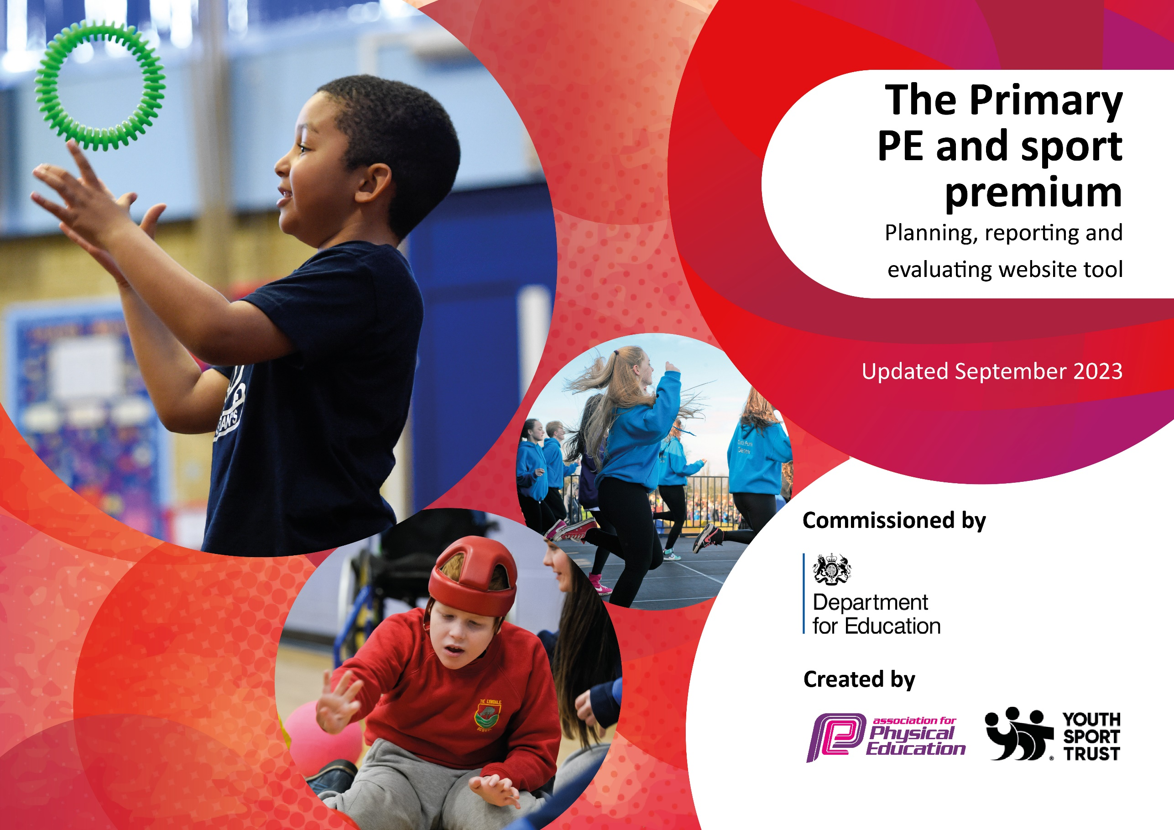

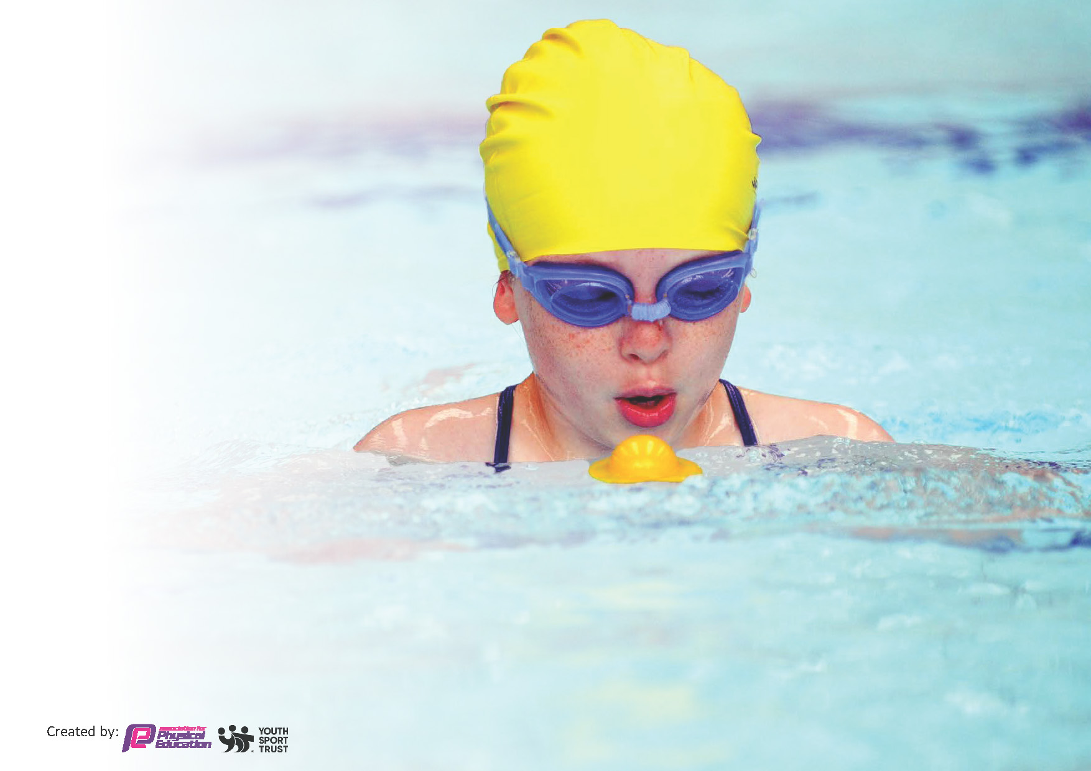
This template can be used for multiple purposes:
by:
- It enables schools to effectively plan their use of the Primary PE and sport premium
- It helps schools to meet the requirements (as set out in guidance) to publish information on their Primary PE and sport premium
- It will be an effective document to support Ofsted inspections enabling schools to evidence progress in Physical Education (PE) and evidence swimming attainment, which forms part of the PE National Curriculum. We would recommend schools consider
the Intent, Implementation and Impact of any spend, as examined within the Education Inspection Framework.

It is important that your grant is used effectively and based on school need.

Schools must use the funding to make additional and sustainable
improvements to the quality of the PE, School Sport and Physical Activity (PESSPA)
they offer. This means that you should use the Primary PE and sport premium to:

- Build capacity and capability within the school to ensure that improvements made now will benefit pupils joining the school in future years
- Develop or add to the PESSPA activities that your school already offers.

The Primary PE and sport premium should not be used to fund capital spend projects; the school’s core budget should fund these. Further detail on capital expenditure can be found in the updated Primary PE and sport premium guidance.

The Primary PE and sport premium guidance, outlines 5 key priorities that funding should be used towards. It is not
necessary that spending has to meet all the key priorities, you should select the priorities that you aim to use any funding towards.

Although completing this template is not a requirement for schools, schools are required to publish details of how they spend this funding. Schools must also outline what the impact this funding has had on pupils’ PE and sport participation and attainment and how any spending will be sustainable in the future. All funding must be spent by 31st July 2024.

The Department for Education has worked closely with the Association for Physical Education (afPE) and the Youth Sport Trust (YST) to develop this template and encourages schools to use it. This template is an effective way of meeting the reporting requirements of the Primary PE and sport premium.
Review of last year’s spend and key achievements (2022/2023)

We recommend you start by reflecting on the impact of current provision and reviewing your previous spend.

Activity/Action | Impact | Comments
School Actions  - Ensure there is a range of quality teaching resources for the delivery of high-quality PE lessons. Ensure there is a wide range of extra-curricular activities on offer with a focus on sports and activities not on the current PE curriculum.  - To increase the passion for PE/Sport with the aim of encouraging healthy lifestyles and participation in physical activity.  - To engage the most reluctant, SEN and PPG children. To provide opportunities for the most reluctant, SEN and PPG children to represent the school in sport competitions, whilst maintaining the opportunity for more able children to compete.  - To provide extra swimming lessons for children – particularly Year 6.  - Increased engagement in intra-school sports. | - New resources bought to allow us to deliver a high quality engaging curriculum. All staff have access to specialist sports coach and are now delivering an hours P.E. with their children. The other hour is delivered by sports HLTA.  - Specialist coaches KS1 after school football club. Joel Pilkington delivered specialist PE provision across all Key Stages.  - SSP organized a range of inclusive sports competition for all year groups, abilities and gender across a wide variety of sports. These competitions took place during and after school around the local area. clubs delivered for PPG, least active and SEN. Multiskills sessions delivered before school 3Xpw.  Staff supported in after school competitions when needed. STMM competed in 35 competitions during academic year 2022/23.  - Years 3- 6 swam over the course of the year  - Through the local SSP, STMM have competed in a variety of competitive events and have ensured that children from all year groups, gender, social/economic and ability have taken part (12 competitive events). | - All school resources to be reviewed in September 2023. Questionnaire to be re-issued in September 2023. New starters within teaching staff. Staff to continue to teach 1 lesson of P.E  - 2. SSP to be renewed for academic year 2023 to 2024. Lunchtime resources to be reviewed in September 2023. Staff to continue running clubs. Accrington Stanley to deliver Learn to Move Healthy Lifestyle lessons to Y5. Continue developing the Forest School activities, including EYFS.  - Targeted clubs to continue (most clubs open to all pupils). Teacher skills and knowledge to be developed through CPD in house and SSP. Ensure that we have an ‘active 60 approach to the teaching and delivery of P.E.  4. School swimming lessons took place weekly over the course of the year. Sessions increased from 45 minutes to 90 minutes to help build water confidence in pupils. Target for increasing number of year 6 to achieve 25m and the more of Year 5.  - Staff to continue running clubs. Accrington Stanley to continue delivering Move to Learn Healthy Lifestyle lessons to Y5.  Continue to develop the Forest School activities, including EYFS. Look to develop more sports for clubs etc. Look to bring in more whole school activity days to broaden curriculum, improve teacher skills and develop pupil engagement.  Competitive competitions remain a priority for STMM. Continue to use SSP competitions and develop intra-school competitions.

Key priorities and Planning
This planning template will allow schools to accurately plan their spending.

Action – what are you planning to do | Who does this action impact? | Key indicator to meet | Impacts and how sustainability will be achieved? | Cost linked to the action
Ensure there is a range of quality teaching resources for the delivery of high-quality PE lessons.  Ensure there is a wide range of extra-curricular activities on offer.  To provide a range of games and activities at lunch time led by the lunchtime supervisor to be given responsibility of organising lunchtime activities with support when needed and make use of playtime leaders.  Morning sports club 3Xpw for breakfast club children EYFS – Y6  Staff to continue running clubs, discussing healthy lifestyle and further develop the Forest School activities, including EYFS.  Buy into SSP for year 2023/24. Continue to buy into HRVS Sports Partnership. Enter relevant competitions, ensuring boys and girls, least active, SEND, PPG and all ability groups are involved.  Work with Accrington Stanley FC in the Community to offer more ASC  Ensure all children are engaged in 30 minutes of active activities per day. | Update resources for curriculum PE. Sports Co-ordinator to continue to receive CPD. List of resources to be completed in June/July 2024.  Buy resources for playtimes, lunchtimes and before / after school sport. Use specialist coaches provided by SSP and in house staff. Continue to offer clubs for Y1 to Y6, all abilities, SEND, PPG and least active.  At least match number of clubs from previous year.  Timetable lunchtime supervisors to work with different groups during lunchtimes. Develop the role of playtime leaders to assist in the delivery of activities at lunchtime.  Keep a register of lunchtime participants & try to encourage least active/PP/SEN children to join in.  Multiskills activity club to be run by JP - sports coach and a TA.  Range of ASC provided to give children greater access to a range of sports.  SSP organise events over the course of the year – attend as many as possible with a range of pupils. Sport lead and staff to select appropriate competitions and arrange cover/support and put on diary.  ASFC in the community to offer ASC.  P.E. to arrange clubs in September 2024.  Lead lunchtime supervisor to organise activities for different year groups during playtimes/lunchtimes. Develop the role of playtime leaders to assist in the delivery of activities at lunchtime. | KI 1: Increased confidence, knowledge and skills of all staff in teaching PE and sport  KI 2: Engagement of all pupils in regular physical activity  KI 4: Broader experience of a range of sports and activities offered to all pupils.  KI 2: Engagement of all pupils in regular physical activity  KI 4: Broader experience of a range of sports and activities offered to all pupils.  KI 2: Engagement of all pupils in regular physical activity  KI 4: Broader experience of a range of sports and activities offered to all pupils.  KI 5: Increased participation in competitive sport  KI 3: The profile of PE and sport is raised across the school as a tool for whole school improvement | Resources to be used for academic years to come. Training of all staff ensures continuity and ability to offer clubs for future academic years.  Training of all staff ensures continuity and ability to offer clubs for future academic years.  Training of relevant staff to ensure continuity and ability to offer clubs in future years. Site ready for use. Organise training for play leaders from Y3-6.  Continue to employ JP coaching to support breakfast club. Ensure resources are suitable.  Provide time for staff to organise clubs with pupils. Support from SLT.  Opportunities for children to represent school in competitive events – allow staff time to organise teams and attend events.  Continue to build relationships with ASFC.  Relevant training and support for staff. Suitable resources available. Time to organize and prepare activities. | PE co-ordinator time  £1000 resources.  Staff time and  £1500 resources  Courses for Play Leaders training -  JP – Sports coach – portion of £7500 - £4500  £1500

Continue to provide opportunities for all children to access high quality PE/Sport.  To increase the passion for PE/Sport with the aim of encouraging healthy lifestyles and participation in physical activity.  To improve assessment of PE within school using Lancashire P.E. Passport.  To provide opportunities for the most reluctant, SEN and PPG children to represent the school in sport competitions, whilst maintaining the opportunity for more able children to compete.  To increase the role of children within sport and as playground leaders and Eco club.  To increase the profile of PESSPA within school.  To provide swimming lessons for greater number of children to raise water confidence (Covid 2021  lockdown Impact) and raise end of Year 6 swimming data.  To ensure teacher subject knowledge and CPD is current and appropriate.  To continue to increase the confidence of staff in curriculum delivery.  To continue to increase the confidence of staff in curriculum delivery.  To continue to deliver a wide range of sports & activities via PE lessons & extracurricular clubs (across EYFS, KS1 & KS2). Increase the % of children who take part in extracurricular clubs, being actively engaged in sporting activities  To provide opportunity for children across the school to represent the school in a competitive intra school and in house events. Maintain or aim to increase the number of inter-schools’ events through links with local schools & the SSP To continue to develop personal challenge opportunities in school. | Sports co-ordinator in role to oversee the PE curriculum delivery, wider school sporting opportunities and supporting teachers to deliver at least one hour of P.E. per week with their class.  External providers (through SSP/JP coaching/ASFC in the Community) to continue to offer after school clubs and P.E. lessons where relevant to enhance pupil skills, performance and upskill teaching staff. ASFC to deliver healthy lifestyle lessons across in Y5. Focus on one class per half term.  Updated P.E. Passport app to be downloaded on all teacher iPads in the first week in September. CPD delivered to all staff in Autumn 1 through P.E coordinator to ensure usage and consistent approach to assessment. All assessment to be recorded on app.  Continue to develop & run morning and after school sports clubs. Some clubs targeting least active/ PPG/ SEN, some coaching for competitions & clubs for access by all. Keep register and target specific groups alongside P.E/ Subject Leader  Develop the role playground leaders to assistant in delivering games at lunchtime and to be sport ambassadors. Training began in 2023-24. Use school council/ECO club to promote healthy eating choices around school.  Obtain School Games mark. Use the School Games Mark action plan to identify areas for improvement - more inter and intra school sporting competitions.  All children from Y2 to Year 6 to have swimming lessons – at least half a term.  Questionnaire to go out to all teaching staff in September 2023. CPD to be organised where and if required. Use peer to peer training, SSP & ASFC in the community if possible. Buy in CPD if necessary.  To continue to identify areas of PE to develop with staff and to support their development in PE. Teaching staff to continue to deliver one P.E. lesson per week to their class.  Staff questionnaire.  Staff to attend relevant CPD PE courses & training (network meetings, twilights etc) run by the SSP to enhance or extend current opportunities.  CPD opportunities to further develop staff knowledge both inhouse & externally - cascade CPD training to other staff members.  ECTs and new starters to work with Sports Co-ordinator/class teacher/sports coach in PE lessons to upskill and embed knowledge.  P.E. subject lead to support PE via observations, drop ins, team teaching, planning meetings. Use specialist coaches to disseminate knowledge and skills in a variety of sports.  Maintain and build relationships with other schools within and outside of the academy & arrange & participate in friendly events. Plan & hold competitions within our own school so all children can access intra-school events. Participate in inter school events/ competitions run by the SSP Develop/increase the opportunity for personal challenges in PE lessons, sports clubs and during lunchtime club sessions  Build a resilience culture in children through competition, support and targeted events. Organise, coordinate/ enter more sport competitions or tournaments within the school &/or across the local area, including those run by sporting organisations. Match or exceed our previous number of school games events and SSP organised competitions in order to maintain our gold mark & work towards the platinum mark. Increase the number of pupils who participate in the School Games. Target PPG, SEND, least active and reluctant children. | Key Indicator 1: Increased confidence, knowledge, and skills of all staff in teaching PE and sport.  Key indicator 2: The profile of PESSPA being raised across the school as a tool for whole school improvement.  Key indicator 5: Increased participation in competitive sport.  Key Indicator 1: Increased confidence, knowledge, and skills of all staff in teaching PE and sport.  KI 2: Engagement of all pupils in regular physical activity.  KI 4: Broader experience of a range of sports and activities offered to all pupils.  KI 3: The profile of PE and sport is raised across the school as a tool for whole school improvement  KI 3: The profile of PE and sport is raised across the school as a tool for whole school improvement  KI 4: Broader experience of a range of sports and activities offered to all pupils.  Key indicator 3: Increased confidence, knowledge and skills of all staff in teaching PE and sport.  Key indicator 5: Increased participation in competitive sport. | Relevant PD for staff and support from Sports Co-ordinator and SLT.  Wider range of clubs for pupils to attend with chance of representing school at competitions.  Continue to subscribe to PE Passport from Lancashire.  Support and PD from Lancashire and Sports Co-ordinator.  Sports co-ordinator and staff to choose events from HRVSSP to attend.  Staff who began well-being warriors last year to look into playground leaders training for relevant pupils.  Sports co-ordinator to look at requirements to be met to obtain School Games Mark.  Continue to use Accrington Academy pool for lessons.  Sports co-ordinator, SLT and staff to source relevant PD.  As above  Sports co-ordinator to evaluate feedback from staff questionnaire.  Discuss relevant PD for staff and adaptations to sports provision  Continue to sign up to HVRSSP and attend events. | £1000 for teachers to undertake CPD.  £1500  £699  £1000 to subsidise external providers  Source training through SSP  £14,000 – portion from Sports Premium - £7500  As above  As above

Key achievements 2023-2024
This template will be completed at the end of the academic year and will showcase the key achievements schools have made with their Primary PE and sport premium spending.

Activity/Action | Impact | Comments
Greater participation in HRVSSP organised events – this included events for children with SEND.  Subsidised Y1 and 2 football club in place run by ASFC.  Large number of children attending breakfast club also involved in morning multi-skills club.  More ASC available for children to take part in. | Increased number of pupils experiencing representing school in competitive sport  Engaged children of younger age in team sports and provided qualified coaching sessions.  Greater number of children taking part in 30+ minutes exercise before the start of the school day.  Increased number of children attending ASC and

Swimming Data
Meeting National Curriculum requirements for swimming and water safety.
Priority should always be given to ensuring that pupils can perform safe self-rescue even if they do not fully meet the first two requirements of the National Curriculum programme of study

Question | Stats: | Further context  Relative to local challenges
What percentage of your current Year 6 cohort can swim competently, confidently and proficiently over a distance of at least 25 metres? | 60% | Use this text box to give further context behind the percentage.  e.g., 30% - we are struggling to get pool space due to our local pool closing so we have had to use a much smaller local school pool. We have had to limit the number of pupils attending swimming lessons during one term which means some pupils have attended fewer swimming lessons than others.
What percentage of your current Year 6 cohort can use a range of strokes effectively [for example, front crawl, backstroke, and breaststroke]? | 73% | Use this text box to give further context behind the percentage.  e.g., Even though your pupils may swim in another year please report on their attainment on leaving primary school at the end of the summer term 2024

What percentage of your current Year 6 cohort are able to perform safe self-rescue in different water-based situations? | 17% | Use this text box to give further context behind the percentage.
If your schools swimming data is below national expectation, you can choose to use the Primary PE and sport premium to provide additional top-up sessions for those pupils that did not meet National Curriculum  requirements after the completion of core lessons. Have you done this? | Yes/No
Have you provided CPD to improve the knowledge and confidence of staff to be able to teach swimming and water safety? | Yes/No

Signed off by:

Head Teacher: | Helen Bird
Subject Leader or the individual responsible for the Primary PE and sport premium: | Damian Wilson – Acting Deputy Headteacher, Sports co-ordinator.
Governor: | Natalie Moore – Chair of Governors
Date: | 30/07/24

